
Research Report: Padv1 DashPass Value (acp-confidential-cadoc)
OCT 2022 DRI: Kelly Peterson CORE TEAM: Kevin FuPeter SergelJordan CainesKay JacksonKatie CoffeeLouis Vitti Nathan DinhLouis FioreMeghan Desai Julia Kripke

| Business Context

There are ~100M Cx US-wide that place <2 orders a month on DoorDash. These “Occasional Cx” represent a significant opportunity for growth for DD. If we are able to increase these users OF, we can not only grow DD GMV, we can make the DashPass value prop more compelling for these Cx and convert them into long term retained / DP users.
On 10/21, DoorDash will be running a new experiment exploring “total fees” and distance based pricing for both classic and DashPass Cx in Austin and Virginia Beach. For this experiment to work longer term we must understand how DashPass Cx may react to this concept and identify the top value props of DashPass Cx as it relates to affordability and so as to inform fee structures that continue to comport with our legal obligations.

| Previous Research
The team has explored the needs of Occasional Cx and Feedback from EPIC 1 prior to this phase

- September Research Insights Monthly: Affordability Across the App (acp-confidential-cadoc)
- [Results] TFD: M2 DashPass Messaging research
- Churned Occasional Cx Research Report
- Churned Cx Flat Fee Test: Research Brief
- Why do Cx visitors drop-off? (US only) Q3 2022 | Part 1. Interview Insights

| Research Questions:
- What are the top pain points of DashPass Cx as it relates to fees
- How do DP Cx feel about fees today? How aware are they of fees.
- How do DP Cx feel about distance based pricing? How does this differ by awareness of service fees?
- Ho do Cx feel about seeing a “total fee” upfront?

| Methodology:
The Cx Research Team conducted an online survey with 848 DashPass Cx excluding those in Chicago.

| Concept Shown:
You see a Total Fee as soon as you start browsing on the DoorDash app. The Total Fee includes your DashPass $0 Delivery Fee and reduced Service Fee combined into one flat amount that doesn’t change with your order subtotal. And Total Fee gets lower for restaurants closer to you. The closest restaurants are $0 Total Fee so you can enjoy truly free and fast delivery.

| TLDR & Recommendations
- DashPass Cx are not fully sure how service fees are calculated for DashPass but know that they are different with each order
- DashPass Cx are interested in the concept of total fees and would find it useful but are not sure how it might impact their ordering and DashPass status
- To date about a quarter of Cx believe they typically place orders over $50 with at least 60% of Cx ordering for more than just themselves
- When asked about their thoughts on Total Fees and Renewing DashPass Cx stated they appreciated the transparency but felt didn’t like experiencing any fees as a DashPass customer.
- Most Cx felt somewhat undecided because they needed more information. Without context of how much the fees are, it felt difficult for them to understand.

DashPass Cx will need greater education on how Total Fees works and how it saves them money beyond just service fees to ensure strong understanding and retention.

| KTs from Qual:
- DashPass Cx may not fully understand the savings they will get until they get to checkout, need to make this clearer upfront.
  - They may think there is a new fee at first
  - In particular this could become confusing when comparing across apps
- Quality concerns may work against distance based pricing as some Cx view that further away orders may be lower quality so paying more for them doesn’t feel right
  - Most Cx seem to find distance logical because they feel that is how delivery works in general, however, without a threshold (e.g. I know my fees will never be more than XX) they are having a really hard time grasping this
  - KP personal note: I feel like my further away orders are more likely to be batched and then I experience this
- Nearby pricing may be interesting for Cx who frequently use pickup on DashPass to get the $5 credit and may shift them to delivery in these scenarios
  - We may want to do a test with messaging targeting these folks once we GTM
- One Cx was from NC and felt that DoorDash was “punishing” him for living in a less populated area with distance based pricing because there is just less that is close to him
  - KP question: are we thinking about changing the goal posts for different regions or market types?

| Survey Results

Overall DashPass Reactions to Total Fees:

DashPass Cx think that seeing the “total fees' ' feature will be useful when shopping on DoorDash. However, the majority of Customers are “fence sitters” in terms of action with 50+ % indicating that they are neither more likely or less likely to change ordering behaviors based on “total fees” functionality.

Generally speaking, how useful do you find the new “total fees” feature on DoorDash?
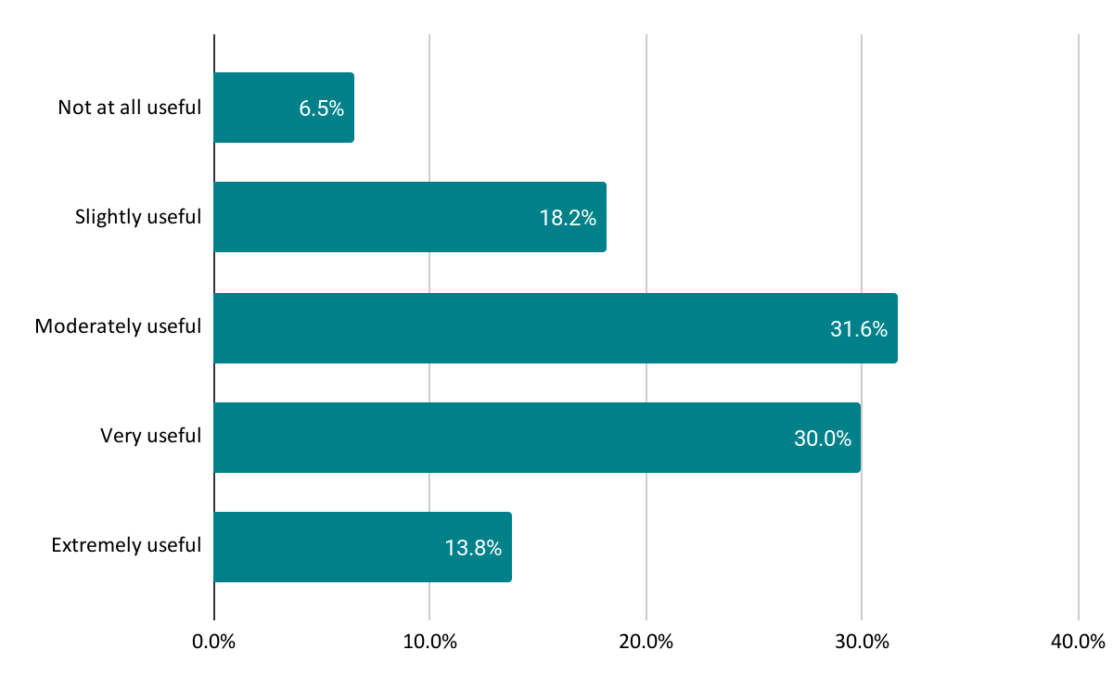
Would having “total fees” on DoorDash make you more or less likely to place an order on DoorDash in the next two weeks?

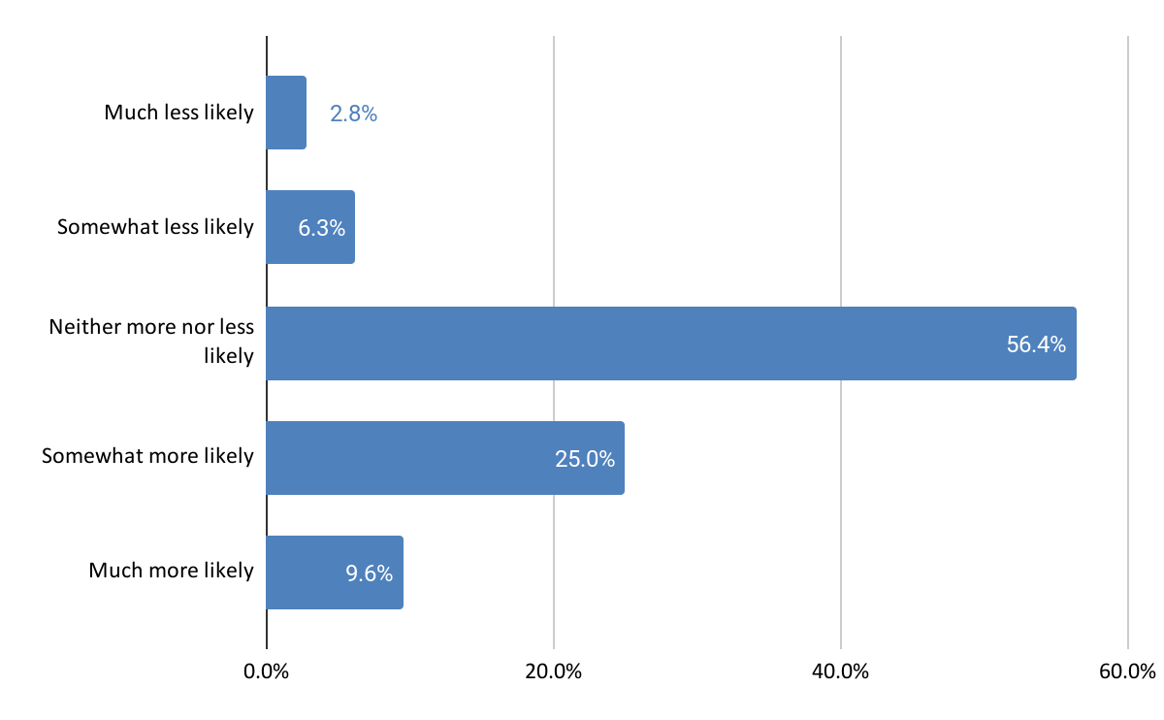

Knowledge of DashPass benefits:

What fees do you pay as a DashPass Cx?
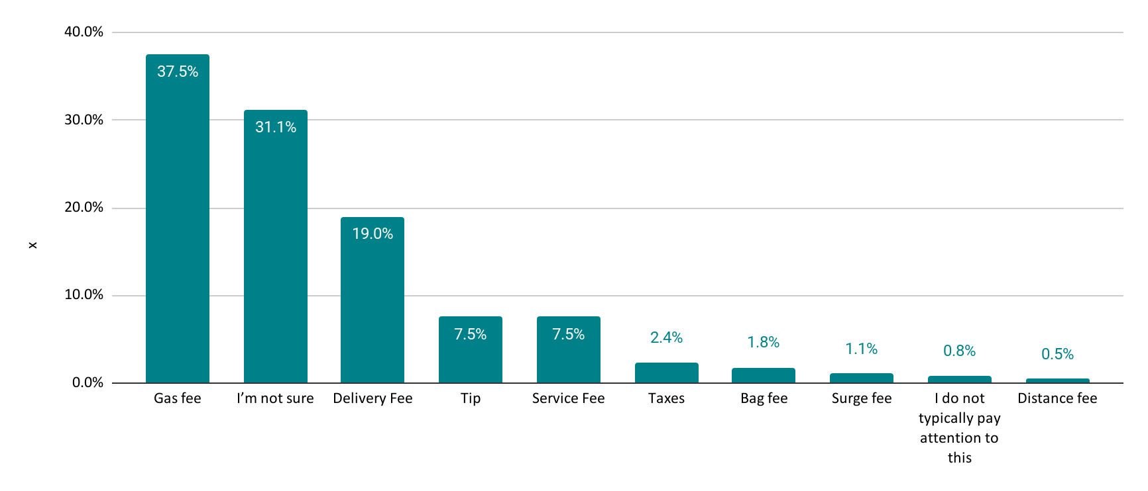
How do Service Fees work across orders on DashPass?
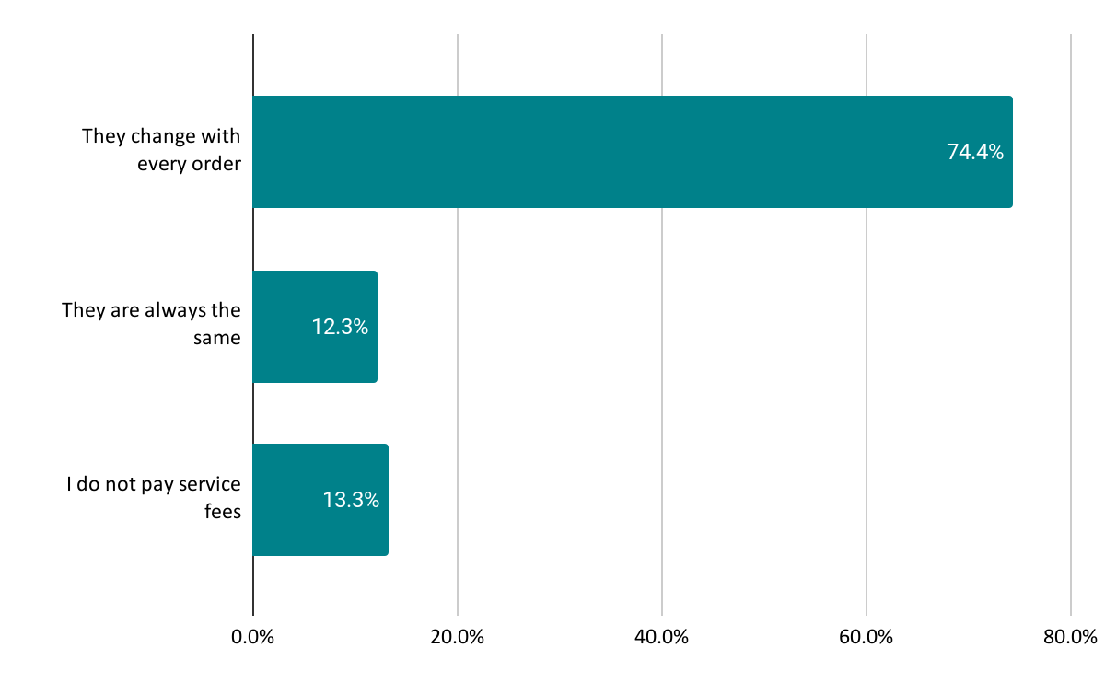
How do Service Fees work on DashPass?
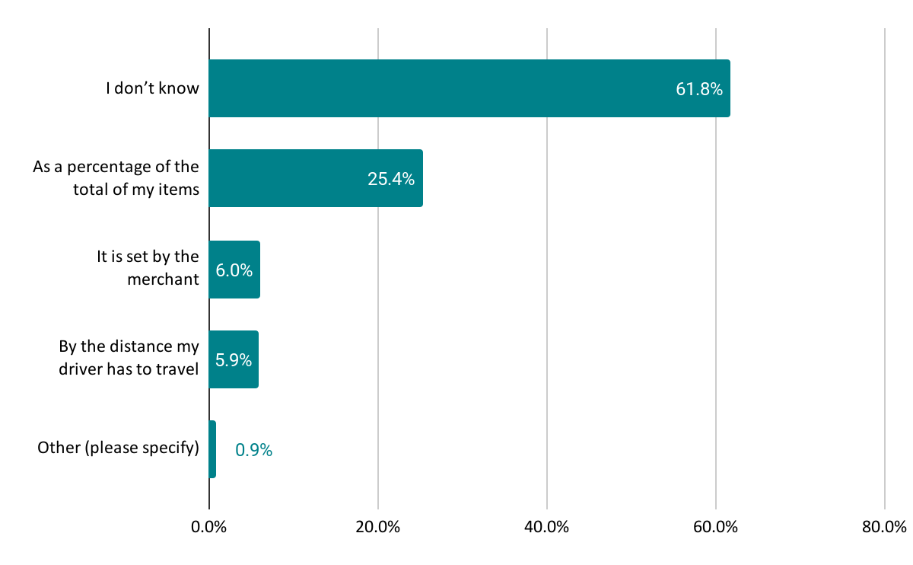

DashPass and ordering experience:

Which of the following best describes the item subtotal on a typical order?
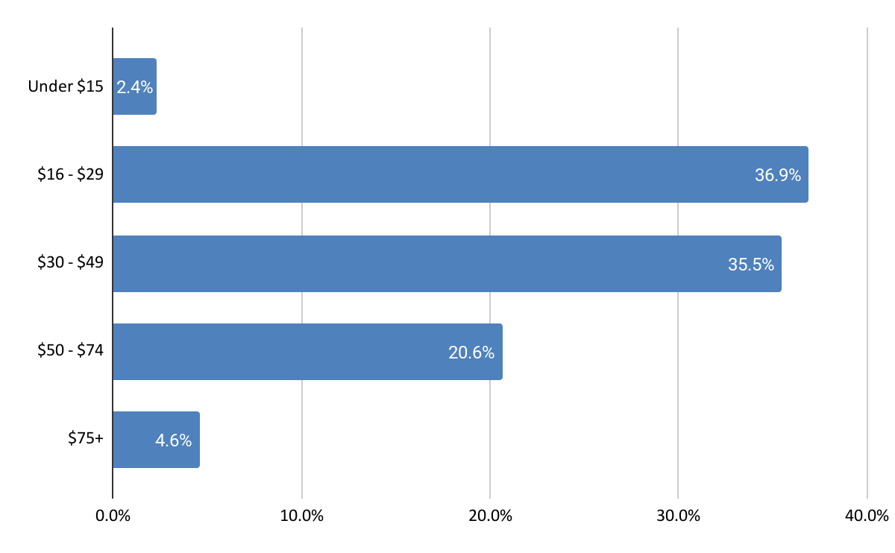
Which of the following people do you typically order for when ordering food on DoorDash?
